Crosswoods News
August 2022

We have a new board!
I want to start by giving thanks to the following board members that are retiring:
Joe Vonderheide - President
Mark Farley - Treasurer
Sarah Hanna - Secretary
Becka Vonderheide - Board Member and Association Organizer

After decades of service to the Crosswoods Neighborhood Association, they are turning over the keys to a new group. Joe, Mark, Sarah & Becka have cared for this neighborhood selflessly and with extreme dedication. I for one am thankful. The new board consists of:
Matt Winkler – President
Zeke Walters – Vice President
Evan Ball – Treasurer
Helena DiBiasie - Secretary

End of summer is here (bummer)
I can honestly say that in my 25+ years here in this neighborhood, that was one of the hotter ones. And driest. And wettest. I couldn’t figure it out, nor could our flowers. Landscaping took a beating as did some yards, but all in all the neighborhood looks good. (NO ARMY WORMS!!)
We are trying to keep the entranceways looking professional. If you have any suggestions, I’d be happy to hear them.
Fall Yard Sale on 10/1/22
We will be having the Crosswoods Neighborhood Yard Sale on 10/1 from 8am – 2pm. Let’s hope the weather is cooperative and that the Cats/Ole Miss game is a night game. CNA will put signs out and advertise the event.

Fall Hazardous Waste Clean-up
Got a bunch of old paint, chemicals, batteries, and other hazardous items laying around the garage? Jessamine County will be having a collection event for Jessamine County residents also on 10/1 from 8am – 4pm at the Convenience Center, 123 Hendren Way. We have attached a list of items they are accepting.
Storm Drains
Please help us keep the storm drains clear in our neighborhood.
Storm drains are meant to collect this water as well as the runoff from roofs and landscaping. If a storm drain becomes clogged with leaves or debris, excess water can flood the property.

Brannon Road Expansion
I am sure most of you are aware of the expansion plans for Brannon Road. Attached is the response I got from Joshua Samples from KYTC when I asked for an update.
“The project right-of-way and utility phases have begun. We hope to start making right-of-way offers in the next couple of months. The construction phase is currently in fiscal year 2025 which begins in July 2024. Hopefully all of the right-of-way will be purchased and the utilities moved by then. The Legislature will still have to keep funding for construction in the 2024 highway plan, but they usually do keep the funding going once we have started buying right-of-way.”
As we get more information, we will pass it along through the monthly meetings as well as on the website.
Membership Drive
This year we asked for $75 from each household to fund the CNA. These funds go towards keeping the entrances looking professional, utilities for entrance lights, street sign repairs, and a dozen other things you would never expect. Many residents are not aware that these items need funding, and many feel it is unnecessary. Heck, I’m guessing 20% have already thrown this newsletter in the trash. Full disclosure, I was one of the people who neglected to look into the CNA dues to understand how much they were needed. But now I know the importance of it and ask that all of our neighbors do as well. Since we average less than 65% participation, we are looking at ways to make it easier to pay, whether online, through Zelle, things like that. We will have updates when we send out the January Newsletter. If we get a little more participation, we would love to lower that number to $50 per household. But we really need more support in the numbers department.
If you would like to pay your 2022 dues, please send your dues of $75.00 to
Evan Ball
64 Lantern Way
Nicholasville, KY 40356
Please make sure we have your address. Thank you in advance!

Closing notes
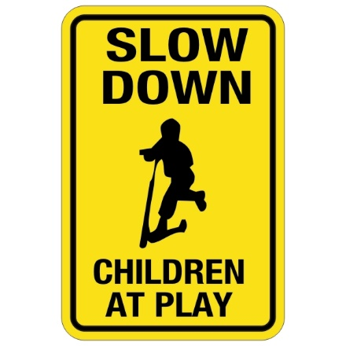
The thing I hear complaints about the most is the speeding and running of stop signs in the neighborhood. Many families have small children and pets, so that is one thing I hope can improve.
We usually have the monthly meetings the first Tuesday of each month 5:00 pm at Southland Christian Church, Building A, Chapel. You are welcome to attend, or if you would rather keep up with everything that is going on by checking out the website you can.
www.CROSSWOODSSUBDIVISION.COM or Crosswoods subdivision Facebook page
If you have any concerns, comments, or questions, please email us at:
crosswoodsna@gmail.com or cna4mail@yahoo.com

